Experiment 6

Student Name: Lakshay Aggarwal UID: 25MCI10047
Branch: MCA (AI/ML) Section/Group: 25MAM-1(A)
Semester: 2-SEM Date of Performance: 03/03/2026
Subject Name: Technical Training - 1 Subject Code: 25CAP-652

- Aim of the Session:

Learn how to create, query, and manage views in SQL to simplify database queries and provide a layer of abstraction for end-users.

- Software Requirements:
- PostgreSQL
- pgAdmin
- Windows Operating System

- Objectives of the Session:
- Data Abstraction: To understand how to hide complex table joins and calculations behind a simple virtual table interface.
- Enhanced Security: To learn how to restrict user access to sensitive columns by providing views instead of direct table access.
- Query Simplification: To master the creation of views that pre-join multiple tables, making reporting easier for non-technical users.
- View Management: To understand the syntax for creating, altering, and dropping views, as well as the naming conventions required for efficient data access.

- Theory:

A View is essentially a virtual table based on the result-set of an SQL statement. It does not contain data of its own but dynamically pulls data from the underlying "base tables".
- Simple Views: Created from a single table without any aggregate functions or grouping. These are often updatable.
- Complex Views: Created from multiple tables using JOINs, or including GROUP BY and aggregate functions. These provide a consolidated summary of the database.
- Security Layer: In enterprise environments, views are used to grant permissions on specific subsets of data. For example, a "SalaryView" might exclude the "Employee_SSN" or "Home_Address" columns for privacy.
- Benefits: They simplify the user experience, ensure data consistency across reports, and reduce the risk of accidental data modification by providing read-only abstractions.

- Practical / Experiment Steps:

Step 0: Creating sample tables and inserting records

Code:

CREATE TABLE departments (

dept_id SERIAL PRIMARY KEY,

dept_name VARCHAR(50)

);

CREATE TABLE employees (

emp_id SERIAL PRIMARY KEY,

emp_name VARCHAR(50),

status VARCHAR(10),

salary INT,

dept_id INT REFERENCES departments(dept_id)

);

INSERT INTO departments (dept_name) VALUES

('HR'),

('IT'),

('Marketing'),

('Sales');

INSERT INTO employees (emp_name, status, salary, dept_id) VALUES

('Lakshay', 'ACTIVE', 50000, 2),

('Neha', 'ACTIVE', 60000, 3),

('Tushar', 'INACTIVE', 40000, 2),

('Priya', 'ACTIVE', 70000, 4),

('Tanu', 'ACTIVE', 45000, 1),

('Palak', 'INACTIVE', 30000, 1);

SELECT * FROM departments;

SELECT * FROM employees;

Output:

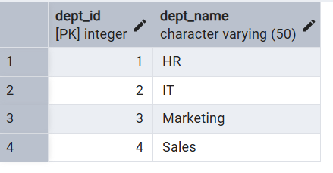

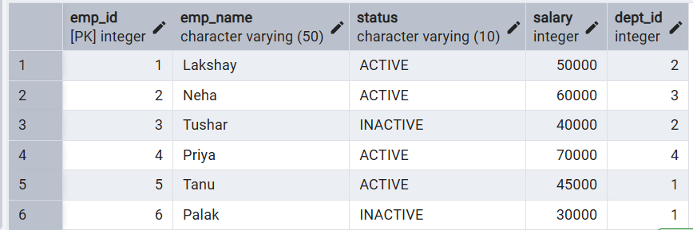

Step 1: Creating a Simple View for Data Filtering

Implementing a view to provide a quick list of active employees without exposing the entire table structure.

Code:

CREATE VIEW active_employees AS

SELECT emp_id, emp_name, salary

FROM employees

WHERE status = 'ACTIVE';

SELECT * FROM active_employees;

Output:

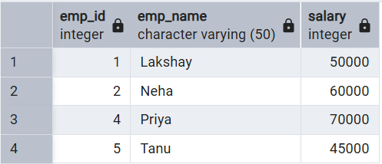

Step 2: Creating a View for Joining Multiple Tables

Simplifying the retrieval of data distributed across Employees and Departments tables.

Code:

CREATE VIEW employee_department_view AS

SELECT

e.emp_id,

e.emp_name,

d.dept_name,

e.salary

FROM employees e

JOIN departments d

ON e.dept_id = d.dept_id;

SELECT * FROM employee_department_view;

Output:

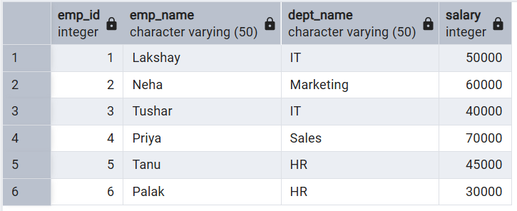

Step 3: Advanced Summarization View

Creating a view to provide department-level statistics automatically.

Code:

CREATE VIEW department_statistics AS

SELECT

d.dept_name,

COUNT(e.emp_id) AS total_employees,

AVG(e.salary) AS avg_salary,

MAX(e.salary) AS max_salary

FROM departments d

LEFT JOIN employees e

ON d.dept_id = e.dept_id

GROUP BY d.dept_name;

SELECT * FROM department_statistics;

Output:

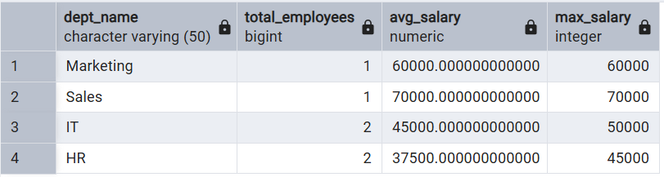

- Learning Outcomes (What I have learned):
- Abstraction Proficiency: Students will be able to create and query views to simplify efficient data access and abstraction.
- Security Implementation: Students will understand how to use views for data masking and providing restricted access to sensitive information.
- Syntactic Accuracy: Students will demonstrate the correct syntax for creating and querying views, ensuring logical clarity in naming conventions.
- Real-world Application: Students will be able to design views for practical domains like Library Management Systems or Payroll Systems to demonstrate functionality.

